UN Environment GEF PIR Fiscal Year 2019
- July 2018 to 30 June 2019)
- Identification |  |  | GEF ID.: 5390 | Umoja no.: GFL/5060-2711-4E04
Project Number + Project Title |  |  | Sustainable Pathways – Protected Areas and Renewable Energy (SPPARE)
Duration months | Planned |  | March 2015 – March 2019 (48 months)
Duration months | Extension(s) |  | March 2019 – March 2020 |  | 12 months
Division(s) Implementing the project |  |  | GEF Biodiversity and Land Degradation Unit,  Ecosystems Division
Name of co-implementing Agency |  |  | n/a
Executing Agency(ies) |  |  | Department of Environment – Ministry of Health, Wellness and the Environment, Antigua and Barbuda
Names of Other Project Partners |  |  | - Ministry of Finance and Corporate Governance  - APUA Water Business Unit  - APUA Electricity Business Unit  - Ministry of Health and the Environment  - Abu Dhabi Fund for Development (ADFD)  - International Renewable Energy Agency (IRENA)  - UNEP  - Her Majesty Prison  - Fire Department  - NGOs  - Ministry of Housing, Lands and Urban Renewal  - Ministry of Agriculture, Fisheries and Barbuda Affairs  - Ministry of works
Project Type |  |  | Full Size Project
Project Scope |  |  | National
Region (delete as appropriate) |  |  | Caribbean
Names of Beneficiary Countries |  |  | Antigua and Barbuda
Programme of Work |  |  | UNEP Programme of work (2014-2015) Ecosystem Management and UNEP Programme of work (2014-2015) Climate Change
GEF Focal Area(s) |  |  | Biodiversity, Climate Change
UNDAF linkages |  |  | Outcome 1: Environment, energy, climate change and disaster risk reduction (Component 2, 3 and 4)  Outcome 2: Enabling environment of effective economic and social governance and enhanced security (Component 1)
Link to relevant SDG target(s) and SDG indicator(s) |  |  | SDG 7.2 (7.2.1), 7.b (7.b.1), 13.3 (3.3.2), 13.b (13.b.1), 15.8 (15.8.1), 15.9 (15.9.1), 15.b (15.b.1)
GEF financing amount |  |  | USD 2,639,726
Co-financing amount |  |  | USD 7,980,000
Date of CEO Endorsement |  |  | 4 February 2015
Start of Implementation |  |  | 23 March 2015
Date of first disbursement |  |  | 15 May 2015
Total disbursement as of 30 June |  |  | 1,043,149.17
Total expenditure as of 30 June |  |  | 913,646.13
Expected Mid-Term Date |  |  | October 2018
Completion Date |  | Planned | March 2019
 |  | Revised | March 2020
Expected Terminal Evaluation Date |  |  | 2nd quarter 2020
Expected Financial Closure Date |  |  | 30 April 2021

- OVERVIEW OF PROJECT STATUS

To be completed by UNEP/GEF Task Manager
UN Environment Subprogramme(s)  Insert the Subprogramme(s) and biennia of the PoW to which the project contributes  Subprogramme 1: Climate change  Subprogramme 3: Healthy and productive ecosystems  PoW biennia: 2018‒2019 (although prior biennia over the project history are valid) | Specify the relevant Expected Accomplishment(s) & Indicator(s)  Insert the Subprogramme’s Expected Accomplishment(s) and Indicator(s) to which the project contributes (NOTE: against 2018-19 biennia)  Expected Accomplishment 1(b) Countries increasingly adopt and/or implement low greenhouse gas emission development  strategies and invest in clean technologies  Relevant indicators:  (i) Increase in the number of countries supported by UNEP that make progress in adopting and/or implementing low greenhouse gas emission development plans,  strategies and/or policies  (ii) Increase in climate finance invested by countries or institutions for clean energy,  energy efficiency and/or amount of decarbonized assets  Expected Accomplishment 3(a) The health and productivity of marine, freshwater and terrestrial ecosystems are institutionalized in education, monitoring and cross-sector and transboundary collaboration frameworks at the national and international levels  Relevant indicators:  (i) Increase in the number of countries and transboundary collaboration frameworks that have made progress to monitor and  maintain the health and productivity of marine and terrestrial ecosystems  (ii) Increase in the number of countries and transboundary collaboration frameworks that demonstrate enhanced knowledge of the value and role of ecosystem services  Expected Accomplishment EA3(b) Policymakers in the public and private sectors test the inclusion of the health and productivity of ecosystems in economic decision-making  Relevant indicators:  (i) Increase in the number of public sector institutions that test the incorporation of the health and productivity of marine and terrestrial ecosystems in economic decision-making
Describe any progress made towards delivering the stated PoW Expected Accomplishments and Indicators. State key changes since previous reporting period. [Section to be shared with relevant Regional and Global SubProgramme Coordinators]

The project is designed to demonstrate how financial flows from investments in, and sale of renewable energy can be ploughed back into protecting critical ecosystems under a sustainable financing model embodied within the Sustainable Island Resource Framework (SIRF) Fund. The project advanced steps toward operationalization of the SIRF Fund and the establishment of wind generation and PV infrastructure. In this period contracts have been awarded to commence installations. Related, the GEF resources have been used to lever additional significant external funding for the RE installations and will be undertaken soon. The project will invest in recreational tourism infrastructure as part of the Boggy Peak National Park, the revenue from which will be also be cycled through the SIRF Fund in a model to fund biodiversity conservation in the country. Contracts are soon to be awarded to initiate construction of an interpretive centre and trail system in the national park. Linked to the investment in the interpretive center and trail system is the strengthening of management of the ecosystem assets in Boggy Peak National Park with engagement of the landowners and stakeholders. The project also made some progress in preparatory actions toward landscape restoration through removal of invasive species that have high fire hazard potential.

For all GEF 6 and later projects:
GEF Core Indicators  Insert core indicator(s) from Core Indicator Worksheet to which the project contributes | Indicative expected Results  [add figure approved at CEO endorsement/ approval]  N/A
Indicative expected Results
[add figure approved at CEO endorsement/ approval]
N/A
Describe any progress made towards meeting the indicative expected results as per the approved project documentation. Describe any key changes since previous reporting period

N/A.

To be completed by Project Manager, as relevant
Planned linkages with UNDAF | Describe progress towards the UNDAF strategic objective to which the project contributes.  [Section to be shared with Monitoring Unit within PPD]  The UNDP Sub-regional country programme for Barbados and the Organization of Eastern Caribbean States (2017-2021) under sub-regional priority 3 ‘Sustainable ecosystems and natural resources’ seeks that legal and regulatory frameworks, policies and institutions enabled to ensure the conservation, sustainable use, and access and benefit sharing of natural resources, biodiversity and ecosystems, in line with international conventions and national legislation.

Planned contribution to relevant SDG target(s) and SDG indicator(s) | SDG 7 – Renewable Energy  Targets and indicators:  7.2 By 2030, increase substantially the share of renewable energy in the global energy mix  Indicator 7.2.1 Renewable energy share in the total final energy consumption  7.b By 2030, expand infrastructure and upgrade technology for supplying modern and sustainable energy services for all in developing countries, in particular least developed countries, small island developing States and landlocked developing countries, in accordance with their respective programmes of support  Indicator: 7.b.1 Investments in energy efficiency as a percentage of GDP and the amount of foreign direct investment in financial transfer for infrastructure and technology to sustainable development services  SDG 13 – Climate Action  Targets and indicators:  13.3 Improve education, awareness-raising and human and institutional capacity on climate change mitigation, adaptation, impact reduction and early warning  Indicator 13.3.2 Number of countries that have communicated the strengthening of institutional, systemic and individual capacity-building to implement adaptation, mitigation and technology transfer, and development actions  13.b Promote mechanisms for raising capacity for effective climate change-related planning and management in least developed countries and small island developing States, including focusing on women, youth and local and marginalized communities  Indicator 13.b.1 Number of least developed countries and small island developing States that are receiving specialized support, and amount of support, including finance, technology and capacity-building, for mechanisms for raising capacities for effective climate change-related planning and management, including focusing on women, youth and local and marginalized communities  SDG 15 – Life on Land  Targets and indicators:  15.8 By 2020, introduce measures to prevent the introduction and significantly reduce the impact of invasive alien species on land and water ecosystems and control or eradicate the priority species  Indicator 15.8.1 Proportion of countries adopting relevant national legislation and adequately resourcing the prevention or control of invasive alien species  15.9 By 2020, integrate ecosystem and biodiversity values into national and local planning, development processes, poverty reduction strategies and accounts  Indicator 15.9.1 Progress towards national targets established in accordance with Aichi Biodiversity Target 2 of the Strategic Plan for Biodiversity 2011-2020  15.a Mobilize and significantly increase financial resources from all sources to conserve and sustainably use biodiversity and ecosystems  Indicator 15.a.1 Official development assistance and public expenditure on conservation and sustainable use of biodiversity and ecosystems

[complete the fiscal year and select: 1st PIR; 2nd PIR; …. Final PIR. Add more columns if needed]
Implementation Status | FY 2016 | FY 2017 | FY 2018 | FY 2019
Implementation Status | 1st PIR | 2nd PIR | 3rd PIR | Final PIR

[complete the fiscal year in the first line; select HS; S; MS; MU; U; HU; unknown; not rated to rate the progress towards the development objective for the fiscal year you are reporting in the second line. Add more columns if needed]
Development Objective Rating FY | FY 2016 | FY 2017 | FY 2018 | FY 2019
Development Objective Rating FY | S | MS | U | MS
Describe progress made towards achieving the project results as per table 3.1. State key changes since previous reporting period. The information here must be consistent with the assessment and justification provided under 3.1. THIS IS THE SAME DESCRIPTION AS IN THE ‘PROGRESS RATING BOX IN SECTION 3”

The most important development, which has positively impacted project implementation in the last year, has been the hiring of a new Project Team to increase productivity and address the recommendations made in the latest Mid-Term Report. A project coordinator was hired in Q1-2019, as a well as one project technical officer for Component 2 and 4 in Q1 and Q2, respectively. In Q2-2019 the team also welcomed a Renewable Energy technical Officer responsible for Component 3 of SPPARE, as well as an in-house civil engineer hired to help on aspects of SPPARE component 2 and 3, among other DoE projects. Both technical officers and the in-house civil engineer are being guided by the project coordinator (PC) with assistance from the DoE’s biodiversity technical officer and deputy technical officer, and with oversight by the Project Manager (PM). Due to a large number of synergies existing between the SPPARE project and the GEF-funded Pathway to 2020 project, project PCs have been collaborating to achieve objectives more efficiently, including the formulation of a joint TOR for protected areas business plan consultant. Similarly, the Biannual Update Report has similar objectives relating to the carbon sequestration and mitigation objectives (component 3 & 4) of SPPARE, and thus the carbon sequestration data collection and training consultancy (forest Finest consultancy) was shared between projects. Such collaborative approaches ensure the project outcomes are met in the most efficient and effective way forward.

The Environmental Management and Protection Act (EPMA) 2019 has been gazetted and a consultant has been hired to develop a business plan for the SIRF fund. The EPMA outlines the SIRF fund board’s composition and responsibilities; the latter includes the approval of the SIRF fund business plan currently being drafted (finalised by Q4-2019). This will ensure money is allocated towards the newly establish protected area so that project outcomes survive past the project’s completion date. The development of the Boggy Peak business plan will ensure the SIRF fund board is aware of the finances needed for park management as well as the revenue expected to be generated from the park. A consultant has been engaged for the development of said business plan.

The EPMA 2019 will also positively impact the project going forward by establishing the necessary legislative framework for land protection and protected area financing through the SIRF fund. The team has changed the workplan to address the necessary steps involved in protecting Boggy Peak under the EPMA, including extensive engagement with the general public and in-person discussion with landowners within the park boundaries. The development of the legislation required to regulate activity within the park is now unnecessary as the EPMA 2019 calls for the protected area’s management plan to be this regulatory document. Financing the protected area will be a direct result of the team’s effort to establish the necessary park infrastructure, including the interpretation centre and a network of trails. The latter was not identified as an activity in the original workplan but was deemed necessary to meet the desired goal of charging an entrance fee into the park. The green card system concept, including the consultants required for the implementation of these works, is awaiting the completion of the infrastructure to be put in place. The team has been in correspondence with the developers of the green card system however, so that the consultancy can begin when the infrastructure is taking shape (Q1-2020).

Wind turbines and solar PV systems from Vergnet and GreenTech Solar suppliers are in the process of being shipped for installation. While major setbacks have resulted from a lack of collaboration and information sharing from other government departments, the Minister and Prime Minister have recently expressed long-term goals for the transition from fossil fuels to renewable energy. We expect this change in priority at the higher level will influence government stakeholders to better collaborate with the project team on this initiative. Furthermore, the team has sought assistance from the US National Renewable Energy Lab (NREL) for third party assistance in the review of technical documents and methodologies for RE technology installation. The project team endeavours to have sites selected ready by mid Q4-2019 for all turbines and solar panels to be installed by the end of Q1-2020. The lack of activity towards achieving this project goal in the project’s first 3 years will likely result in many post-installation project activities, such as power purchase agreement negotiations with APUA and thus revenue from RE into the SIRF fund. Nonetheless, the project team will ensure the institutional and regulatory instruments necessary for the DOE to generate revenue post-project will be in place.

The project goal of enhancing forest ecosystems through tree planting, invasive species control and wildfire prevention has largely been placed on hold in last several years, due to both drought and a lack of capacity to adequately monitor the initiative. The new team is working with multiple national and regional partners to merge these goals into one initiative in order to increase the likelihood of success. The department has sent a formal invitation to the Organization of Eastern Caribbean States (OECS) to partner on creating a wildfire prevention strategy template for member states and a national strategy for Antigua. An expert consultant in wildfire prevention and forestry has been identified to commence work in Q3-2019. Engagement with the fire department for wildfire prevention as well as the active involvement of schools in the tree planting and monitoring exercise will ensure that the overall project goal of restoring forests and increasing the carbon sequestration potential of the protected area are met. Carbon sequestration consultants have been hired (Q2-Q3- 2019) to quantitatively assess the mitigation and sequestration potential of the activities completed through the SPPARE project. The wildfire prevention strategy consultancy is expected to start in Q3-2019, while the educational campaign and lemongrass removal and tree planting exercise are expected to take place in tandem with the department’s arbour month in Q4 (annual tree-planting initiative).

[complete the fiscal year in the first line; select among H; S; MS; MU; U; HU; unknown; not rated to rate the implementation progress in the fiscal year you are reporting in the second line. Add more columns if needed]
Implementation Progress Rating | FY 2016 | FY 2017 | FY 2018 | FY 2019
Implementation Progress Rating | S | MS | U | MS
Describe annual implementation progress, including any significant [expected and unexpected] environmental or other changes (Results) attributable to project implementation. Also, please discuss any major challenges to meet the objectives or specific project outcomes. [section will be uploaded into the GEF Portal ‘Information on Progress, challenges and outcomes on project implementation activities’ and is the primary report that viewers can see before opening the detailed PIR]. The information must be consistent with the assessment and justification provided under 3.2.

Outcome 1 – Revenue for Protected Areas increased by $2 million annually
The overall goal of this component is to develop the necessary guiding documents and institutional structure to generate revenue for protected areas. The Environmental Protection and Management Act (EMPA) 2019 was gazetted in June 2019, allowing for some project activities that were placed on hold to progress. Specifically, this included the designation of the SIRFF board, the approval of the SIRFF business plan and the designation of Boggy Peak as a protected area. The SIRFF Board composition was amended and it is now expected that the board will hold their first meeting in Q3-2019. A consultant was hired in Q2-2019 to re-draft the SIRF fund business plan (previous version was not deemed satisfactory by the PM) which will be finalized and approved by the SIRF fund board in Q4-2019.

Several synergies were identified between the SPPARE project and the GEF-funded Path to 2020 project, which commenced in Q1-2019. The project teams have met several times to discuss how activities align and how project consultancies can be used to maximize the impact and efficiency of outcomes from both projects. The first being the need to establish a comprehensive management and business approach to Protected Area (PA) systems across Antigua. Project coordinators have merged the PA business plan consultant Terms of Reference in order to maximize the value of this consultancy, and to ensure that the business plan developed for Boggy Peak National Park (BPNP) under the SPPARE project is consistent with the National PAs business plan under the Path to 2020 project. A consultant has been procured for the position and is expected to commence work in Q3-2019.

Following extensive issues with the board and fiduciary management, the Department of Environment requested to be removed as a board member on the Marine Ecosystems Protected Areas (MEPA) trust fund board. In the coming year, the DoE will resign as founding government partner for the MEPA trust, which will signal the completion of the department’s responsibility to operationalize the fund with the final step being the establishment of the Permanent Board. Disbursement to the MEPA trust will take place following a fund evaluation and the completion of all relevant audits.

Outcome 2 – Improved Management Effectiveness of New Protected Areas
Similar to PA business plans, PA management plans should be relatively consistent across the country. Significant efforts have been made by the project team in Q1-Q2 2019 to improve the draft management plan for the BPNP through: (1) attending and successfully completing a PA management plan development workshop in February, (2) the development of a comprehensive stakeholder engagement plan by March, (3) extensive engagement with community and government stakeholders via workshops and in-person meetings between April and July and (4) the integration of data collected through consultation and national/international online resources into the management plan. The outcome will be a management plan organized according to international standards and based on all relevant local knowledge and scientific data. The management plan draft will be reviewed by internal reviewing committees, the Technical Advisory Committee as well as by the PA business plan consultant (mentioned above in Outcome 1). Consultations have been successful, with high attendance and participation, particularly during community workshops (see Annex 2 for a story highlighting this aspect of the project).

The building of the interpretation centre for the BPNP was revived in Q1-2019 after being placed on hold due to issues in the contractor procurement process. Following a failed tendering in process in 2017, the project team explored the possibility of contracting the National Housing Authority (NHA) to complete the works. Despite consistent communication with the project team, NHA failed to produce a proposal for the project team. The project team thus sought help from the National Parks Authority, whom have had extensive experience in building interpretation centres in Antigua from a historical perspective. They provided the team with two recommendations of contractors they had worked with before, both of which submitted proposals based on the original drawings. An evaluation was conducted, and the contract was later awarded in July. The original building drawings are being revised to be in-line with the budget provisions and future building uses. The contract for the architect and engineer has been awarded for contract administration and supervision, while an in-house civil engineer will assist the project manager and coordinator in managing the project. It is expected that the building will be completed by May 2020, assuming that there are no undue delays.

A preliminary assessment of the site for the interpretation centre was made in March to assess the potential for Solar Photovoltaic technology to be installed. The team is currently assessing the most cost-effective RE technology to power the interpretation centre.

Outcome 3 – At least 100,000 tonnes of Co2 equivalent emissions avoided as direct impact of the pilot with immediate plans for 1,000,000 tonnes of CO2.
The site selection process for the wind turbines and solar photovoltaic (PV) systems has proven to be the most challenging aspect of the SPPARE project. Several government agencies, all with differing agendas, must provide information and/or approval to the project team to move forward with site selection, especially as it pertains to wind turbine installations. Lengthy delays have resulted from the team’s inability to receive critical approval from the Eastern Caribbean Civil Aviation Authority (ECCAA) and grid-connection information from the Antigua Public Utilities Authority (APUA). This is a direct result of a lack in collaboration and transparency among departments. Nonetheless, in Q2-2019 ECCAA provided a list of accepted sites, which included the Sir Vivian Richards Stadium and Parham Ridge on the north side of the island. The team is now (Q3-2019) concentrated on obtaining the necessary information for Vergnet to complete the electrical studies for the sites. Proposals for geotechnical works have been submitted to the department and a team of evaluators will be awarding a contract in Q3-2019. The tender for civil works has been distributed in July-August and the department is awaiting applications for the completion of the works to be evaluated by September. Greentech solar is expected to provide designs for solar PV systems from RFP1 in Q3-2019, which will be used to provide training to local installations teams and build local capacity for these works in the future.

Although additional funding was obtained to purchase RE technology (Abu Dhabi Fund for Development), the department was encouraged to submit a second application to the fund for a second disbursement in Q2-2019. A new technical and financial feasibility study was thus produced by the team, which may ensure RE installations continue post project completion.

The inventory tracking system is being developed and finalised for the end of July, which includes compiling all receipts and shipment packing slips to ensure all parts received are tracked. All components for RE wind installations which includes the main components to the structure (nacelles, blades, tower, etc) were received by June 2019, with additional components being shipped following Vergnet’s electrical studies to be completed by the end of September.

Outcome 4 – Fires reduced nationwide by 20% by project end.
The project team designed a Knowledge, Attitude and Perceptions (KAP) surveys to understand community KAP in regards to wildfires in Antigua. Two-hundred and fifty (250) surveys were administered to community members surrounding the Boggy Peak Area in Q2-2019. A second survey was designed specifically for farmers and will be administered in Q3-2019. Terms of reference were published for the Wildfire Prevention Strategy Consultant, responsible for the development of a national strategy, the training of the fire department in communicating and implementing this strategy, as well as aiding the project team in selecting spaces of high lemongrass (fire-propagating invasive species) concentration for the replanting of fire and drought resistant tree species. The latter will actively fight wildfire spread by creating a fire resistant barrier between susceptible forested land and agricultural areas. The organization of Eastern Caribbean States (OECS) has expressed interest in collaborating on this initiative through the development of an OECS template for wildfire prevention strategies and using Antigua and Barbuda as a pilot area. This would enable the project team to work alongside other OECS member states that have conducted similar projects, increase the impact of SPPARE activities and bring Antigua to the forefront in wildfire prevention within the eastern Caribbean. An official letter requesting this partnership was sent to the OECS and the consultant has been selected for the work (to begin in Q3-2019 and complete in Q4-2019). A Memorandum of Understanding shall be signed in Q3-2019 between to OECS and DoE, which will outline responsibilities moving forward.

The construction of the Victoria Gardens Nursery is awaiting approval from the Ministry of Works to supply base construction materials and labour to begin construction. This nursery will help provided the necessary seedlings for the planting of trees in the project site (mentioned above). The team is working with local experts and online resources to come up with a variety of resilient and fire-resistant native tree species. The aim is to have fruit bearing trees included in the mix to increase food security on island, as well as to involve local community groups and schools in the tree planting process. The involvement of the local community in this initiative is imperative for seedling growth success and community engagement/awareness.

[complete the fiscal year in the first line; select H; S; M; L; to rate the fiscal year you are reporting. Add more columns if needed]
Risk Rating | FY 2016 | FY 2017 | FY 2018 | FY 2019
Risk Rating | M | M | S | M
Describe key changes since previous reporting period. Projects with ESERN rating high medium/ high risk must refer to the safeguards implementation plan and its implementation.
[section will be uploaded into the GEF Portal and in UN Environment Open Platform]
The information here must be consistent with the assessment and justification provided under 3.3

The project was considered at be at substantial risk at the last PIR due mainly to the issues associated with a halt on project disbursements on account of non-compliancy with periodic reporting and submission of audit statements that corroborate the period expenditure reporting. Since the last review cycle, the Department of Environment has put in place a strengthened project management mechanism, with the appointment of a full-time project coordinator with effect January 2019 and support staff in the administrative positions by January 2019 to ensure timely and accurate submission of reporting, particularly on the financial side.

Political will, influence and co-financing from other departments remains a substantial risk to project completion. While endorsement letters were provided by all major government stakeholders at project inception, receiving information from Antigua Public Utilities Authority that is critical to wind turbine installation, in addition to approval from the Eastern Caribbean Civil Aviation Authority for site selection has been detrimental to project implementation in this reporting period. Furthermore, assistance in the form of labour from the ministry of works has been difficult to access. Overall, the project needs to gather more attention from senior government officials to gain the support necessary to move activities along in time for project completion. The PM and PC are aware of the necessary actions that need to take place to mitigate these risks and will start them in Q3-2019.

Receiving further disbursement remains a critical risk to project activities, especially as the project progresses into Q3-Q4 2019. The PC and the accounting team have continued to make efforts to submit accurate reports, yet timely submissions remain an issue. The PC will mitigate these risks by taking on some of the financial reporting responsibilities and better managing the accounting team progress according to timelines. The PC also will ensure higher level of detail and accuracy in future reports to minimize all future delays. Activities have progressed despite a lack of second disbursement, and unless the project can receive funds in the early part of Q3, many activities will have to placed on hold and current contract agreements may be jeopardized. This risk will be mitigated in the future by ensuing necessary disbursements are made well before project activities are begun.

Finally, the gazetting of the EPMA in this reporting period is a positive step towards completing activities in Component 1. Nonetheless the board has yet to be convened and the risk that this doesn’t take place in a timely fashion (in time to approve the SIRF fund business plan being developed and make negations with APUA for a power purchase agreement) remains a risk to be addressed in the next reporting period.

Stakeholder engagement | Describe progress, challenges and outcomes on stakeholder engagement (based on the description of the Stakeholder engagement plan included at CEO endorsement)  [section will be uploaded into the GEF Portal]  Stakeholder engagement has been a major priority in the last year. Engagement with several government stakeholders, funding agencies and technology suppliers has been high during the procurement and site selection process for renewable energy installations (Component 3).To ensure transparency, information transferal and active collaboration, the project team is seeking to further engage with key government stakeholders, predominantly the Antigua Public Utilities Authority (APUA), Department of Surveys (topography) and Civil Aviation. Strengthening these partnerships through continuous correspondence may help the project stay on track and minimize further delays. The project team dedicated to declaring Boggy Peak National Park has been in constant contact with local and government stakeholders in the project site since Q1-2019. Two community stakeholder workshops held in May with participation of just over 50 persons from the community, from government departments and industry were held to raise awareness about the project and discuss the values, threats, uses and potential uses of the Boggy Peak area. The team also engaged with government and NGO stakeholders through a special presentation delivered to the technical advisory committee on June 19th. Furthermore, several in-person meetings with key government and private sector stakeholders have taken place. Several best-practices and mal-practices were identified in discussion, especially as it pertains to stakeholders using the area (tourism and agriculture). The information gathered in these consultations has been integrated into the management plan for the area, which will be used to regulate all future activity within the park once it is declared a protected area under the Environmental Protection and Management Act 2019. The project team will focus on reaching private land-owners within the Boggy Peak National Park in the next two quarters. The project team is engaging with the fire department for the wildfire prevention strategy, as well as regionally with the Organization of Eastern Caribbean States (OECS).

Gender mainstreaming | Describe progress, challenges and outcomes related to the gender-responsive measures documented at CEO Endorsement/ Approval in the gender action plan or equivalent. Older projects that were designed before gender mainstreaming should proactively report any possible gender benefits, as appropriate.  [section will be uploaded into the GEF Portal]  Gender considerations, particularly in the Caribbean, are not solely a women’s issue. As such the project looks at yielding advantage to whole communities and benefitting both genders and vulnerable groups. This was a particular focus during community consultations: emphasis was placed on inviting all members of the community, inclusive of socio-economically marginalized individuals living in small rural areas in St-Mary’s parish. Meetings were held in a small school, accessible and approachable by all.

Knowledge activities and products | Provide a narrative of knowledge activities/ products (when applicable), as outlined in knowledge management approved at CEO Endorsement/ Approval  [section will be uploaded into the GEF Portal]  Aside from infographics outlining the various laws of Antigua to land-owners and presentations delivered during BPNP consultations, there were no knowledge activities or products delivered in this reporting period.

Stories to be shared | Optional for mature projects: Provide a brief summary of any especially interesting and impactful project results that are worth sharing with a larger audience, and/or investing communications time in, if any.  [section to be shared with communication division/ GEF communication]  See Annex 2 for site-visits and Workshop pictures with brief summary.

- RATING PROJECT PERFORMANCE AND RISK

Based on inputs by the Project Manager, the UNEP Task Manager will make an overall assessment and provide ratings of:
- Progress towards achieving the project Results(s)- see section 3.1
- Implementation progress – see section 3.2

Section 3.3 on Risk should be first completed by the Project Manager. The UNEP Task Manager will subsequently enter his/her own ratings in the appropriate column.

3.1 Rating of progress towards achieving the project Results(s) [copy and paste the CEO Endorsement (or latest formal Revision) approved Results Framework, adding/deleting outcome rows, as appropriate]

Project objective and Outcomes | Description of indicator | Baseline level | Mid-term target | End-of-project target | Level at 30 June 2019 | Progress rating
Project Objective: Enhanced financing and management of protected areas through innovations in renewable energy capacity and arrangements | CC - Investment in Renewable energy technologies increased  GHG Emissions avoided  SFM – Good management practices in forests | LOI signed. Agreement for 6000 MWh being negotiated  No forest restoration efforts in place in the target areas | - By end of Year 1 APUA will sign PP Agreement with the SIRF Fund  - By Mid Year 2 technical study for scale up will be completed  Specific target restoration areas identified, nurseries established, work plan developed and monitoring system in place.  Wildfire prevention strategy developed | Investment in Renewable energy technologies increased by $16.5M  GHG Emissions avoided, 100,000 Tonnes of CO2 with scale up to 1MtCO2 near term  Good management practices applied in 3,502 hectares forests.  And by relevant economic actors (Antigua Public Utilities Authority)  Wildfire induced invasive decreased in and around protected areas | PPA negotiations are not yet initiated with APUA  Investment in Renewable energy technologies has increased by $15 Million through investment by the Abu Dhabi Fund for Development (ADFD) in 2018 – Second application to the ADFD submitted in June 2019 and awaiting response.  Consultants have been hired in July to assess the carbon sequestration potential of the Boggy Peak National Park, as well as the mitigation potential of the Renewable Energy Technology being installed as part of the project.  Forest management strategy to couple reforestation efforts with invasive citronella lemongrass removal to reduce fire hazard in priority areas was suggested in June. Viable areas of lemongrass growth with the project site have yet to be identified.  Discussions initiated with the OECS Secretariat since June in the formulation of a technical cooperation agreement to assist with the development of a wildfire prevention strategy template for member states; Antigua will be the pilot country to apply this template in development of the national wildfire prevention strategy.  Discussions initiated with the Fire Department since March 2019 to start an educational campaign for wildfire prevention projected for Sept-Dec 2019.The campaign will be based on the National Wildfire Prevention Strategy. | MU-MS
Outcome 1:  Revenue for protected areas systems increased by 2 million annually | The SIRF Fund Business Plan is submitted by the SIRF Fund Board for approval by the end of year 1 | SIRF Fund is created under the Finance Administration Act. No financial strategy in place. The legislation has not yet been passed. Protected areas are funded by the central government | Business plan approved by cabinet.  The financial plan is adopted by the SIRF Fund Board | SIRF Fund begins to accept applications for funding and making small disbursements to cover 10% of recurrent costs | SIRF Fund Business Plan is being developed by a consultant; work commenced in July 2019.  EPMA 2019 passed by the Cabinet of Ministers in June 2019- the SIRF Fund Board will hold their first board meeting in Q3-2019. | S
Outcome 2:  Improved management effectiveness of new protected area (1,719 ha) | Increased financial sustainability of Boggy Peak national park  METT Tracking tools and financial sustainability scores | No model of managed protected area exists.  Funding levels inadequate  METT Score  1. Protected Areas Threat – 34  2. Assessment - 27  3. Financial Sustainability Scorecard - 11 | Conservation areas zone.  Interpretation Center Construction begins  Management plan and implementation begins  METT Score  1. Protected Areas Threat – 33  2. Assessment - 30  3. Financial Sustainability Scorecard - 25 | 50% of the implementation of the Management plan will be funded by Park receipts and the SIRF Fund by the beginning of year 4  METT Score  1. Protected Areas Threat – 32  2. Assessment -33  3. Financial Sustainability - 50 | The Park has been demarcated. Community and Government stakeholder consultation process was completed in May-July 2019. Land-owner consultations are still in progress. The original management plan was revised and edited to include new information and considerations during consultation process. Undergoing final review in Q3-2019.  Redesign of building plans for new site started, contract administrator and construction civil engineers selected in June. The construction contract will be awarded to a local reputable contractor in July. Construction due to commence in Q3-2019.  The BPNP management plan is undergoing a review by international experts to provide further quality assurances for the plan.  METT score to be completed when data from several consultancies are received in Q3-4 2019 | MU-MS
Outcome 3:  At least 100,000 tonnes of CO2 equivalent emissions avoided as direct impact of the pilot with immediate plans for 1,000,000 tCO2 | Avoided emissions of C02 | LOl signed Agreements for 6000MWh being negotiated | Begin negotiations for scale up.  By end of Year 2 Off-takers identified and sign PP Agreement with the SIRF Fund. | Negotiations for scale up are completed.  Reduction of CO2 emissions by project end as indicated through GHG inventory calculations  6MW of off-grid installed on various buildings of various Off-takers including for Reverse Osmosis plants | Framework Agreements and Initial Call-Off Contracts for Solar PV and Wind Turbines signed.  Wind turbine technology shipments (shipments ending in July 2019) and site selection process nearly complete. Delays in installation due to issues relating to government department collaboration are being addressed through increase government department collaboration and ministerial intervention, specifically through increased communication with APUA and discussion with members of Cabinet. | MS
Outcome 4.1:  Fires Reduced nationwide by 20% by the end of the project | Fire induced invasives reduced by 20% in the pilot area  C02 avoided | No national wildfire prevention strategy exists.  SIRMM public announcement still running  No forest restoration efforts in place in the target area | Baseline for awareness of fire prevention approaches established.  Wildfire prevention strategy developed in consultation with relevant stakeholders incorporating the control of invasive species. | Awareness of approaches to wildfire prevention increase 25%  Forested areas sustainability managed to achieve carbon sequestration goals of C02 savings 43,016 achieved | Fire prevention strategy will be developed in Q3-4 of 2019 – Educational campaign will start following the completion of the strategy and training of the Fire department staff. | U
Outcome 4.2 Restoration efforts and avoided degradation lead to projected annual tons CO2 savings 43,216. Potential total carbon benefit of 1,115,709 tons CO2 over 30 years | CO2 savings | Forested areas are partially degraded due to damage by fires and presence of invasive species | National Watershed Management Committee established. | Intervention area re-mapped to represent the efforts achieved.  Forested areas sustainability managed to achieve carbon sequestration goals.  Annual tons CO₂ savings 43,216 achieved | Tree planting exercise will take place in Q4-2019. Sites selected based on presence of invasive species (lemongrass) and location within the park – site selection process will be informed by the wildfire prevention strategy consultant.  BPNP management plan developed and awaiting formal review process with external consultant and internal committees.  Carbon Sequestration consultancy underway since June to calculate total sequestration potential of the BPNP and mitigation potential of RE technology installed. | MU

Overall rating of project progress towards meeting project Result(s) (To be provided by UNEP GEF Task Manager.)

FY2018 rating  [previous] | FY2019 rating  [current] | Justification of the current FY rating and explanation of reasons for change (positive or negative) since previous reporting periods.
U | MU-MS | Summarize the annual progress towards meeting project results. Describe any significant [expected and unexpected] environmental or other changes (Results) negative and or positive attributable to project implementation. State any key changes since previous reporting period. Also, please discuss any major challenges to meet the objectives or specific project outcomes. Whenever possible, please provide evidence of attribution between the UNEP/GEF project’s intervention and observed changes towards the achievement of direct outcomes. In cases where several actors are collaborating to achieve common outcomes, evidence of the nature and magnitude of the UNEP/GEF project’s ‘substantive contribution’ and/or ‘credible association’ should be described.  This information provides the rationale for the Development Objective Rating in Section 2. THIS IS THE SAME DESCRIPTION AS IN THE ‘DEVELOPMENT OBJECTIVE RATING BOX IN SECTION 2”  A significant change which has positively impacted project implementation from the past PIR cycle has been assignment of a dedicated project management team to increase productivity and address the recommendations made in the Mid-Term Review that as concluded in October 2018 and further to the 2018 PIR. A project coordinator was hired in Q1-2019, as a well as one project technical officer for Component 2 and 4. In Q2-2019 a Renewable Energy technical Officer was assigned to Component 3 of SPPARE. An in-house civil engineer hired to help on aspects of SPPARE component 2 and 3 (this engineer is assisting with other DoE projects)..  A critical challenge the plagued the project was the extended period to bring the periodic project reporting up to date and finalization of the 2017 audit, by the DOE, all of which had to be approved by the fund management office. This delay prevented disbursements to the project subsequent the second disbursement in January 2016. Without any further cash disbursements, commitments particularly for the major infrastructure components could not have moved. The DOE made concerted efforts in this report cycle to bring all reporting to compliance permitting the third disbursement to made to the project in May 2019. Consequently the project has moved ahead with the initiation of tenders for the infrastructure work.  A key achievement critical to the operaltionization of the SIRF Fund under Component 1 was the gazetting of the Environmental Management and Protection Act (EMPA) in June 2019 that was a prerequisite. The DOE had been instrumental in mobilizing high-level ministerial support to address this challenge. This will now allow for establishing the necessary legislative framework for land protection and protected area financing through the Fund. This will pave the way for the constitution of the SIRF Board and associated decision making and permit the initiation of revenue inflows/grants within business plan that is being completed. The project management team is advancing the related components that include the construction of the interpretation centre and trail attraction at the Boggy Peak park and the Green Card system that will contribute to capitalization of the Fund under Component 2.  Another significant result (Component 3) reported in the last period was the access to additional funds secured ($15 million from the Abu Dabi Fund for Development) for the purchase of wind turbines and solar PV systems from Vergnet and GreenTech Solar suppliers, which are now in the process of being shipped for installation. There however remains some level of lack of collaboration and information sharing from other government , and the DOE has been soliciting the support of the responsible minister to assist. Recent policy pronouncements by Prime Minister on long-term goals for the transition from fossil fuels to renewable energy is anticipated to influence government partners in expanding collaboration. Furthermore, the project was able to secure assistance from the US National Renewable Energy Lab (NREL) for third party assistance in the review of technical documents and methodologies for RE technology installation. The project team hopes to have sites selected by mid Q4-2019 and ready for all turbines and solar panels to be installed by the end of Q1-2020.  Overall there has not been much movement in Component 4 from the last PIR cycle. The project team is working with multiple national and regional partners to do some level of integration in the work planning for the reforestation and the fire risk suppression so as to accelerate progress. The DOE has sent a formal invitation to the Organization of Eastern Caribbean States (OECS) to partner on creating a wildfire prevention strategy template for member states and a national strategy for Antigua as a member state. Carbon sequestration consultants have been hired (Q2-Q3- 2019) to quantitatively assess the mitigation and sequestration potential of the activities completed through the SPPARE project.

Risks to the delivery of results
The second column should be completed by the Project Manager and the third column should summarize the recommendations that the Project Manager and Task Manager have agreed upon to address the problem/risk. Projects should complete only the relevant sections and are free to add/delete problems/risks. This section should inform the risk rating in section 3.3.

Problems/risks identified | Description of the problem/risk | Agreed recommended actions
On achieving targets | Management Structure | Fill capacity gaps in the project management by recruitment of required personnel. This has been achieved through the hiring of a full-time project coordinator and two technical officers for component 2 and 3. Consultants and internal staff have been hired/engaged as needed.
On achieving targets | Internal communication | Strengthen internal communications through weekly meetings, email and phone communication among team members to ensure the project coordinator is informed of progress and can make informed and timely decisions. Make use of Smartsheets* an internal project implementation tracking tool to ensure team members are aware of timelines and responsibilities.  * Smartsheets is a process/project management software platform being used by the DOE
On achieving targets | Work flow | Ensure project workflow is monitored by the project manager through monthly reports submitted through Smartsheets. Project coordinator tracks monthly progress through Smartsheet deadlines and through weekly meetings.  Generally accelerate all processes, particularly with respect to mobilization of consultancy/ contracts and other procurements for the construction/installation of the major infrastructure.
On achieving targets | Reporting | Improve the timeliness and accuracy of periodic (quarterly expenditure and forecast) reporting to Anubis. The accountant has a key role here. This is to be monitored by the project coordinator.
On achieving targets | Financial management | As per above, ensure timely and accurate monthly internal expenditure reports, quarterly expenditure reports on Anubis as well as initiation and completion of yearly external audits (and internal bi-annual audits) are made. This is essential to facilitate timely cash disbursements.
On achieving targets | Capacity gap in engineering and construction sector | Fill technical capacity gap through recruitment of an internal civil engineer. This was done effective June 2019.
On stakeholder engagement | Engagement with community stakeholders and government partners | Increase outreach to stakeholders particularly those surrounding the BPNP in order to gain support for its protection. Expand engagement of government partners, specifically the APUA and the ECCAA to minimize further delays in receiving information and obtaining needed approvals. Strengthen engagement with the fire department to facilitate the selection and procurement process for the wildfire prevention initiative.
On environmental, social and gender safeguards | Environmental, social and gender safeguard monitoring | Seeking active engagement of farmers, schools, tourism operators and rural communities, inclusive of women and marginalized social groups. Development of social impact assessments and management plans were applicable.
On sustainability of results | Project results are maintained/monitored after project completion | Facilitate the process to ensure the SIRF fund board is operational before project completion will be key to ensure the sustainability of Component 1 deliverables. Hasten the installation of a management body for the BPNP so as to ensure deliverables from component 2 are sustained.  Ensure that multi-year operational support and maintenance provision requirements are included in the contracts with the RE technology suppliers. Strengthen and support efforts to ensure  continued commitment of the Government of Antigua and Barbuda at the policy level to transition to renewable energy to ensure outputs from Component 3 are maintained and continued. Build a much closer collaboration with the fire department for Component 4 in development of the wildfire prevention strategy linked to the removal of lemongrass and reforestation effort.

3.2 Rating of progress implementation towards delivery of outputs

Outputs | Expected delivery date | Implement-ation status as of 30 June 2018 | Implement-ation status as of 30 June 2019) | Progress rating justification (as much as possible, describe in terms of immediate gains to target groups, e.g. access to project deliverables, participation in receiving services; gains in knowledge, etc) | Progress rating
Output 1.1: Business plan for the System of Parks and Legislation  (Activities: EPMA legislation, Business plan for SIRF fund and BPNP) | January 2020 | 62% | 75% | EPMA 2019 Legislation gazetted in June 2019 and SIRF fund board appointed accordingly (to convene). The consultant has begun re-drafting the SIRF fund business plan in June (due for completion/review in Q4-2019). The consultant for the BPNP business plan has been engaged with and is due to start in Q3-2019 (due to complete in Q1-2020). | MS
Output 1.2 Financing and Operational Framework of the SIRF Fund  (Activities: develop SIRF fund regulations, operational manual, accounting and procurement rules and appoint the SIRF fund board) | December 2016 | 100% | 100% | All activities complete. | S
Output 1.3: Capacity Building of SIRF Management  (Training for SIRF fund operations and procurement) | May 2016 | 100% | 100% | All activities complete.
Output 1.4: Establish the MEPA Trust and other funding streams related to the SIRF Operations  (Activities: operationalize the MEPA trust and make disbursement) | March 2019 | 75% | 100% | The MEPA trust was established in May 2015 and initial disbursement was made to them. Since then, due to reputational risks, the DoE has removed itself as a board member. No funding was provided to other NGO recipients and there are no plans to do so before project completion. | MS
Output 2.1 Legal Declaration of MONP/Boggy Peak  (activities: demarcate boundaries, legislate PBNP under EPMA 2019 and develop management plan) | January 2020 | 85% | 85% | The remaining steps needed to finalize this output are the completion of the management planand the consultations with private landowners. The management plan has been drafted using the comments gathered from all major stakeholders and according to the layout provided during the management plan workshop attended in February. Reaching out to land-owners via tradition media means, contact numbers and communication with the community has had positive results. Some land-owners have not come forward as yet; this will require the team to follow the steps enlisted in the Land Registry Act and EPMA for land designation as a protected area. The demarcation is expected to change to exclude more land-owners along the border of the park, which doesn’t include areas of high biological or environmental importance. | MS
Output 2.2: Financial Agreements in Place for MONP/Boggy Peak  (Activities: establish and collect revenue from Green card system) | March 2020 | 58% | 75% | The Green Card concept note, and marketing launch have been developed. However, without an officially declared park and infrastructure to support visitation, no fees can be collected. Communication between the DOE and green card developers are still ongoing – consultants (TickeTing) are ready to start when infrastructure is further along. | U
Output 2.3: Infrastructure to Support Park Visitation and Sustainable Financing  (Activities: Fencing and signage at Victoria park, application to DCA, Design and construct interpretation centre, outfit centres with RE and EE systems, security cameras and assets to be registered under SIRF) | March 2020 | 68% | 50%  progress re-evaluated over previous PIR | All Victoria park activities have been removed from the project besides the building of the nursery (see Component 4). This was because no entrance fee can be charged for the botanical gardens (free and accessible space for all). The Boggy Peak interpretation centre building has been redesigned for the new building site. The contractor, contract administrator and civil engineer have been selected in June. Contracts will be drafted and signed in late August and Septembre. Redesign will be reviewed and new proposal from the contractor will be submitted mid-Q3-2019. RE tech options are being reviewed and the security infrastructure/personel has been procured by the DOE for these purposes. Construction to take place from Sept 2019-March 2020. Assets will be registered under SIRF fund when board meets in Q3-2019. | MU
Output 3.1: Additional Funds for RE Are Secured  (Activities: financial and technical feasibility studies, negotiate additional funding for RE) | August 2019 | 90% | 100% | A first loan was granted by the Abu Dhabi Fund for Development (ADFD) which was used for the purchase of fifteen 275 Kw wind turbines and solar PV systems for 13 government facilities. A second application was made to IRENA ADFD for funding for additional RE technology. | S
Output 3.2: Sites Prepared for RE Installation  (Activities: Site selection process and RE design, PPA, water levy terms sheet and framework agreements, design inventory management system) | December 2019 | 85% | 85% | Wind: The ECCAA has approved sites (Parham ridge and Sir Vivian Richard Stadium), topographic maps are being developed for each site, a contractor was selected as for geotechnical works to be completed by Q4-2019, the electrical design will be complete by Q4-2019, the civil works tender was published in Q2-2019 and a contract will be awarded to begin works in Q4-2019.  Solar: solar designs have been submitted by GreenTech Solar Ltd and are under review by project team (Q3-2019). Local installation teams will undergo training in Q4-2019 by GreenTech Solar for installation early next year.  PPA, Water Levy, framework agreement: All this is dependent on the development of the SIRF fund business plan (output 1). Negotiations will start when the required information is available.  Inventory management: System has been designed to maintain record of all parts shipped by RE suppliers and will be approved in Q3-2019. | MS
Output 3.3: Equipment is Procured and Installed  (activities: procurement complete, install equipment, negotiate O&M, Registers assets under the SIRF fund) | March 2020 | 85% | 50%  progress re-evaluated over previous PIR | All equipment has been purchased and is being shipped. Installations have yet to start. Operations and maintenance negotiations complete with tech suppliers. Insurance is being purchased for all technology received. Registration of assets under SIRF fund will start following the boards first meeting. | S
Output 4.1 Develop a national wildfire prevention strategy to protect the forest ecosystems.  (Activities: public awareness campaign, national wildfire prevention strategy) | January 2020 | 55% | 65% | Knowledge, perception and Attitude surveys were administered to 251 individuals living in communities surrounding boggy peak. The consultant to develop strategy has been identified and partnership with OECS due to start in Q3-2019. | MS
Output 4.2 Restoration efforts and avoided degradation lead to CO2 savings  (Activities: baseline information collected on carbon sequestration, ESS monitoring, communicate findings and lessons learned) | October 2019 | 70% | 50%  progress re-evaluated over previous PIR | Carbon sequestration consultant has begun works (since June) for Boggy Peak National Park due to complete by end of Q3-2019. ESS monitoring has begun for all project activities. Lessons learned compilation begun by project technical staff. | MU
Output 4.3: Demonstration of Sustainable Husbandry Practices  (Activities: Acquire additional 3 acres of land for plant nursery at McKinnons watershed and remove pests from site prepare tree nursery at Victoria gardens, R&D of sargassum seaweed, install small biogas to convert manure) | December 2019 | 72% | 40%  progress re-evaluated over previous PIR | All activities at McKinnon’s watershed have been placed on hold due to land tenure issues between the DoE’s IWEco project and a private entity whom has made claim to the project site which is hindering the DOE’s ability to continue with project activities. R&D at conferences and through online sources into sustainable uses of sargassum has led to no significant findings and thus this activity is complete. The activity to install a biogass converter has been removed as an activity due to lack of funding and necessary time. The nursery grounds have been cleared at the Victoria gardens for construction, materials have been sourced (not yet procured) and labour is being sought from the MoW to begin construction. | MU

Overall project implementation progress (To be completed by UNEP GEF Task Manager.):

FY2018 rating  [previous] | FY2019 rating  [current] | Justification of the current rating and explanation of reasons for change (positive or negative) since previous reporting periods.
U | MU | The rating of progress in the delivery of outputs should be assessed in terms of both quantity and quality. The assessment must consider ownership by, and usefulness to, intended beneficiaries and the timeliness of their delivery. Use the comments column to explain the reasons behind the success or shortcomings of the project in delivering its programmed outputs and meeting expected quality standards.  The project is demonstrating some acceleration in the latter part of the PIR cycle. There is a concerted effort by the DOE to strengthen project human resource capability and there has been movement on all the project component output delivery. This has also been in response to addressing the recommendations form the mid-term review that was concluded in October 2018. However, against the overall progress that should have been attained at this point in time, advancement still remains relatively low. Progress in Component 1, 2 and 4 has not been as quick as Component 3, that had been relatively more advanced prior to this PIR cycle. Component 1 as linked to the SIRF Fund establishment and installation of a governance mechanism continues to face roll-out challenges that are beyond the control of the project, but the DOE has had some success in advancing commitment of the core stakeholder (and at high policy level) to engage in the process. The challenges in the interpretive centre tendering process and then compounded by the hold on further cash disbursements to the project has resulted in little substantial change in status, however, the project management team has activated the tendering process with construction to start up within the latter part of 2019. Component 3 has seen somewhat sustained movement, albeit slower than anticipated and has also been subjected to the delays due to the hold on cash advances over most of this PIR period. The tendering process has been reinitiated. Component 4 is still moving rather slowly; this was in part due to the limited focussed attention (as noted in the prior PIR) in determining how the project will functionally address on-ground implementation. A promising signal is the engagement of the OECS Secretariat to assist in development of a structed approach that can be applied within the sub-region, using Antigua as a case example. Along with renewed efforts in terms of local partnership engagement, this component should realize an increased implementation rate.

Risks in implementation
This section should be completed by the Project Manager and summarize implementation risks (e.g. procurement delays, reputational risks etc).
The first column should be completed by the Project Manager and the second column should summarize the recommendations that the Project Manager and Task Manager have agreed upon to address the problem/risk. This section should inform the risk rating in section 3.3.

Problems/risks identified | Agreed recommended actions | By whom | When
The project needs to secure the services of an external Chief Technical Adviser (CTA) for a period of at least 6 months, to oversee the re-strategizing of the project, to put the project back on track and to restore the standards and level of compliance required for project delivery and reporting. | Although an external CTA could have provided valuable inputs to both project design and delivery, the cost of hiring such a person would be beyond the means of the project. A suite of new employees, including a project coordinator solely dedicated to the project (who will fulfil many of the roles envisioned for the proposed CTA) as well as two new technical officers were hired to implement the project. In January 2019, the task manager held a multi-day meeting with the team to re-strategize the best methodologies to accomplish project deliverables. This was followed up with a second mission (new task manager) at the start of June 2019 to assess progress. | Project Manager, DOE and the project Management Committee | Q1-2019
Mid-year audits were not conducted, and therefore issues that may have needed corrective measures were not identified until the end of the year. In the MTR review, it was recommended that mid-year (partial) audits be conducted of the project accounts. | Auditing and accounting has been a challenge in prior reporting periods as outlined in the HYPR 2018. During this reporting period, a new accountant was assigned to the project. Monthly expenditure reports are generated by accounts for the project and general audits are performed every quarter. External audits are performed each year for the project. The 2018 audit is to be submitted by mid-Q3 2019. External audits performed each 6 months are impractical and expensive. New procurement procedures, as well as the new staffing of the accounting team have allowed the team to closely monitor expenditures over the last two quarters. | Project Manager, Project coordinator and Accounting Unit | Q3-2019
The project accounts at the Department of Environment are not structured to match or mimic the reporting requirements in ANUBIS. It was recommended in the MTR review that this should take place. | The project team has changed the format of the internal monthly expenditure reports to match the reporting requirements in ANUBIS. | Accounting Unit/ Project Coordinator | Q1-2019
Arrangements need to be made to ensure the SPPARE project have a full complement of full-time project-specific staff at the project coordination and the technical levels, to ensure dedicated attention to the project. | In the last reporting period, a new project coordinator, as well as two new project technical officers were hired to implement the project. The project now has a team solely dedicated to implementation. | Project Manager, PMC | Q1 and Q2-2019
To facilitate better monitoring by the project team, an Annual M&E Plan should be developed and implemented, as a complement to annual work plans. This should also serve as an excellent tool for the participation of the PMC and TAC in quarterly M&E of the project’s implementation progress. | Since Q1-2019, the M&E Specialist provides regular detailed reports every quarter. | M&E Specialist, Data Management Unit | Continuous 2019-2020
The project is failing to stay on track to deliver the outcomes as per the Results Framework and the global benefits anticipated. It was recommended in the MTR review that the UN Environment as the GEF Implementing Agency and the Department of Environment as the project’s Executing Agency, consider the formal extension of the project implementation period, to fully restore the project back on track. | The project was extended to March 2020 to address this issue. Based however on the scope and scale of the infrastructure investments needed under components 2 and 3 and the forestry activities under component 4, the suitability of the project extension duration may need to be evaluated within the course of Q4. | PMC, Project Manager in consultation with the TM | Q4-2019
Areas of intervention and support that would require further financial and technical support, need to be identified in the remaining PIRs to be produced by the project. | Activities that require additional technical support or funding have been identified in Q1-2019. These areas have been addressed as needed (as discussed in section 3.2). The team has also started to identify project outputs that need to continue after the project has ended (Appendix 1) and has started taking action to enable their continuation, including undertaking additional activities such as mapping trails within the BPNP and coordinating with other DoE project teams to identify potential national park management entities. The team will furthermore start identifying potential post-project funding sources for the outputs to be completed. | Project Coordinator, Project Manager | January 2019- March 2020
The project should include a detailed Theory of Change analysis, which thoroughly assesses assumptions and drivers, to allow for early identification of possible intermediate states and alternative outcome to impact pathways, thus allowing for a more diverse identification of project implementation strategies. | The project team has produced and continuously updates a project implementation and management plan, which has further provided the strategy and logic in the implementation of the project. | Project Coordinator, Project Manager and Project Management Unit. | Continuous 2019-2020
The project needs to develop a clear Risk Management Strategy that 1) identifies potential risks to achieving the indicator targets and/or completing the project activities, and 2) proposes strategies for reducing the likelihood of any negative impacts from the identified risks and for reducing the potential level of impacts, for example by pre-identifying alternative approaches to any activities that might have a high level of risk, or pre-identifying key stakeholders (“champions”) who can help the project to overcome barriers that may develop. | The DOE has revised the SPPARE project risk registry to address many of these concerns and recommendations, as described in table 3.3. The project team has addressed many risks, especially as they pertain to addressing delays in land designation for protection or renewable energy installations through enhanced stakeholder engagement and communication with relevant government partners. Specific stakeholder groups that were delaying project progress were identified and ministerial interference was used to address the issues. | DoE Project Manager & DoE Project Coordinator | Quarterly risk register reviews by the PM, PC and PMC
The project needs to improve its work planning. For example, there seem to be a number of gaps between what the project is actually doing and what should be done according to the approved project document (both the lists of outputs-activities and the indicator targets in the Results Framework). The project should therefore develop a detailed workplan for the remainder of the project; this workplan should be based on a careful assessment of what is realistic in terms of timing, and given the disbursed responsibilities of the project team, it should clearly identify which team members are responsible for which outputs / activities. Additional project staff will be granted access to Anubis (as needed) so that they can integrate the work planning that they do in their internal Smartsheet program (the DoE’s cloud-based project management software), which produces dashboard reports generated monthly and presented to the Project Manager, with the work plan reporting that they are required to provide in Anubis. | The re-strategizing of the project with the task manager in January 2019 addressed this issue. The project coordinator is also constantly referring to the project document results framework to ensure that activities are implemented to reach end-of project targets according to approved indicators. Activities that did not support the project’s sought outcomes have been removed or revised accordingly. A revised workplan (2019) has been submitted to reflect these changes. Furthermore, the workflow is tracked using an internal tracking system (Smartsheets) that identifies responsible parties, as well as through weekly meetings with the project team. Information pertaining to project progress, including consultant contracts and reports are being added to Anubis. | DoE Project Coordinator  UN Environment Task Manager | Continuous 2019-2020
The project is currently without a Project Coordinator, and even prior to the departure of the last coordinator the project management was encountering significant challenges. This was probably due to a number of reasons, but one reason was the fact that the coordinator was responsible not only for this project but was also the coordinator for another GEF-funded project, and had other responsibilities on other projects as well. Furthermore, within this SPPARE project responsibility for specific components / outputs was spread across a number of persons, so that the “project coordinator” did not actually have much direct oversight for significant parts of the SPPARE project. | The SPPARE project now has a full-time project coordinator that joined in January 2019. This coordinator does not work on other projects and is responsible for the delivery of all elements related to the SPPARE project. The DOE has provided clarifications on the staffing allocations (in a staffing table) across the various GEF projects being managed by the department so that it is clear in terms of allocation and amounts paid to support staff under this project. | DoE Project Manager | Interim arrangements by October 2018  Permanent arrangements by January 2019
The project very much needs to improve its performance in terms of financial and technical reporting. The project was without funds for a significant part of 2018 due to the fact that is financial reporting was very far behind, and this has compounded the other problems in delivering the project. DOE has taken positive steps to fix this problem by hiring new accounting staff, but the problems remain and it is not clear yet that the new approach will work, in part because responsibility for the financial reporting remains unclear. It is recommended that DOE designate a single person on the accounting staff to be responsible for all financial reporting for this project, with the possibility of also making the project coordinator responsible for some aspects of this (if the new coordinator has the required skills to do so). Once this is done, UN Environment can provide additional training for these persons in the use of the Anubis project management system and in GEF and UN Environment templates and procedures in general. | A dedicated project accountant and administrative staff are assigned to the project. Monthly reports are produced and can be made available. The DOE does struggle with getting good accounting staff, however, new staff within the accounts department has ensured financial reporting is a priority. The project coordinator has also taken measures to personally track project expenditures finances.  UNEP’s programme assistant (Panama) has been guiding both the project coordinator and the accounting staff in reporting to Anubis so as to ensure timeliness and accuracy. | DoE Project Manager and Project Coordinator. | Monthly 2019-2020

3.3. Risk Rating [Insert the Medium and High Risks and mitigation measures identified at CEO endorsement (e.g. Section A.5) and any relevant risk from safeguards screening and/or management plans.] Expand the table to include medium and high risks observed during implementation, e.g. problems identified in sections 3.1. and 3.2.

Risk | Mitigation at CEO approval | Mitigation at implementation | Rank
Component 1
Getting the SIRF Fund operational  All costs not accurately assessed due to external factors such as the mounting cost of climate change  Delay in getting buy-in from the private land owners | Continued discussion and collaboration with the Ministry of Finance to ensure that the Fund is established  Use best estimates available based on previous studies such as Climate Change Centre and other sources plus contingency  Land owners to be actively involved in the stakeholder consultations facilitated by the DCA to develop plan for MONP | Gazetting of the EMPA 2019, which has outlines board composition. The creation of a SIRF fund business plan will be necessary for operationalization. Director of DoE will call first meeting in Q3-2019.  Consultant hired to create BPNP business plan incorporates climate change into analysis.  Landowners actively involved through one-on-one consultations and community workshops. | CEO:
 |  |  | TM: M
 |  |  | PM: M-H
Component 2
Delays in construction of the MONP interpretation centre due to weather and other events’  Volume of visitor traffic could adversely affect biodiversity  Delay in placement of wind equipment due to need for better quality wind data | Construction should start six months before the hurricane season (June –September).  Management plan will provide direction on carrying capacity to guide the level of park traffic  Output 1 must be activated as soon as initial funds are received or GIZ will be approached to upgrade the measurement campaign with a new and different consultant | Delays will be mitigated as much as possible through the contract and the hiring of an adequate contract administration team.  Management plan will provide direction on carrying capacity to guide the level of park traffic.  No longer a risk. | CEO:
 |  |  | TM: M-H
 |  |  | PM: M-H
Component 3
Feasibility is not positive  Proximity of RE installation to Important Bird Areas  Government Lands are not designated in a timely manner for establishment of the wind farm | RETScreen analysis shows the project has a positive NPV. APUA has indicated an interest in purchasing all the output from the pilot at about half of the cost of fuel in electricity production. Project options allow for achieving global benefits with equivalent technical and location options.  A Preliminary EIS was conducted on the Crabbs site and shows that it is not an Important Bird Area. As per the Physical Planning Act, the siting of the RE and enhanced hydro storage would trigger an environmental impact assessment. Consistency with guidelines of the American Bird Conservancy with respect to siting and operation of wind turbines.  Crabbs is now considered one of three sites all of which are intended for wind power development, two with pumped hydro options and Crabbs with Reverse Osmosis modulated dump load.  Opinion at this point is that the Government will be cooperative since the area is not highly populated by sensitive biodiversity. | No longer a risk  No longer a risk as Crabs site was not accepted by civil aviation  This has become the most significant risk to the project. The DoE has mitigated this risk as best as possible by hiring a new team to assist with Component 3 of the project, and by seeking ministerial involvement to increase information transferal and approvals from government partners. | CEO:
 |  |  | TM: M-H
 |  |  | PM: H
Competition for up-scaled investment in RE from developers.  Late payment by APUA  Delay in supply due to manufacturer lead time | Upscale will account for only 30% of demand. The capital structure of the fund will enable it to offer a competitive price without any market distortion. APUA also acknowledges that proceeds from the fund will enhance protected areas a benefit not provided by developers.  The feed-in tariff is about one half the cost of fuel in electricity production and can be reduced later in the project. The possibility of wheeling power over the grid to a large purchaser (hotel) would avoid payment from APUA as the only off-taker.  Order will be placed to coincide with appropriate lead time | Upscale will account for only 30% of demand. The capital structure of the fund will enable it to offer a competitive price without any market distortion. APUA also acknowledges that proceeds from the fund will enhance protected areas a benefit not provided by developers.  The possibility of wheeling power over the grid to a large purchaser (hotel) would avoid payment from APUA as the only off-taker. The team will approach the private sector to address site selection risks as well as payment risks.  This has not been an issue from the Wind Supplier. Green tech solar has been slow to provide designs. To mitigate these risks, pressure is being applied through constant communication with suppliers. | CEO:
 |  |  | TM: H
 |  |  | PM: H
No Agreement for 10MW to be developed over long term, by the Environment Division to generate funding (through the SIRF fund) for the protected areas system.  Intensified storms due to climate change | APUA has indicated a willingness to scale up with the Fund. This is indicated in the LOI.  Retractable or protected wind turbines prioritized as technology choice. Rebuilding and strengthening dams’ structures for resiliency. Forest restoration enhancement efforts take into consideration resiliency. | So far, engagement with APUA has been consistent but progress to gather information has been slow. This will be addressed through the involvement of the minister.  No longer a risk. Retractable wind turbines and hurricane resistant solar technology procured. Forest restoration enhancement efforts take into consideration resiliency. | CEO: M
 |  |  | TM: M-H
 |  |  | PM: M -H
Component 4
Dry weather patterns and lack of public awareness result in increased fires in forest ecosystems, increasing vulnerability to establishment of invasives  Illegal crops in intervention area present potential danger to rangers work and visitation. | Improved fire management integrated into protected areas management plans, will increase sustainability of forest ecosystem services and decrease the spread of invasive species into valuable forest ecosystems.  Public outreach to inform all stakeholders of proposed park activities. Illegal crop activity taken into account in planning and implementation process. | Improved fire management and prevention strategies integrated into protected areas management plan and national wildfire prevention strategy will increase sustainability of forest ecosystem services and decrease the spread of invasive species into valuable forest ecosystems.  No illegal activity reported in project area. Public outreach to inform all stakeholders of proposed park activities should mitigate against this risk. | CEO: M
 |  |  | TM: M
 |  |  | PM: M
Overall Risk Rating  Project Manager |  |  | H
Overall Risk Rating  Task Manager |  |  | H

FY2018 rating  [previous] | FY2019 rating  [current] | Justification of the current risk rating and explanation of reasons for change (positive or negative) since previous reporting periods.
S | H | Elaborate on indicated risks, including climate change, potential social and environmental risks that might prevent the project to deliver the expected results and, whenever possible, the proposed measures to address these risks. Refer also to the assumptions and drivers e.g. when the assumptions are not holding and/ or the drivers are not in place. Please refer to the GEF risk rating table below  The main consideration in downgrading the project risk is the installation of a dedicated project management team to get a better handle on implementation and urgently address the myriad of issues that had been plaguing advancement. Related to the gap in capacity to manage the project was the inadequacy of expenditure reporting in terms of timeliness and accuracy, and the associated lack of up-to-date statements. This undelaying issue has been addressed by the DOE in bringing all the outstanding reporting up to date so as to trigger another cash advance that allowed mobilization of key activities that has been placed on hold.  The main social risks remain associated with stakeholder buy-in where there have been issues (as noted by the project team) in gaining cooperation among some of the core collaborators. Expanding collaboration remains a work in progress and the DOE has made stepped-up efforts particularly in engaging senior government policy makers to facilitate processes. There continues to be need for close stakeholder engagement in the Boggy Peak national park management, particularly on the land tenure issues which have the potential to be contentious.  Environmental risks are not particularly significant although at the broader level, climate change risks are becoming increasingly important in planning. This was the reality in the aftermath of Hurricane Irma that passed over Antigua & Barbuda in 2017 which highlighted the inherent vulnerabilities of wind turbine and PV installations that may be exposed to extreme hurricane conditions. The project is ensuring that installations allow for minimal exposures through design and operational safeguards.

High Risk (H): There is a probability of greater than 75% that assumptions may fail to hold or materialize, and/or the project may face high risks.
Substantial Risk (S): There is a probability of between 51% and 75% that assumptions may fail to hold and/or the project may face substantial risks.
Modest Risk (M): There is a probability of between 26% and 50% that assumptions may fail to hold or materialize, and/or the project may face only modest risks.
Low Risk (L): There is a probability of up to 25% that assumptions may fail to hold or materialize, and/or the project may face only modest risks.

Optional Annexes and/or Links:
- Project Steering Committee Minutes of the year reported
- Half yearly Report
- Quarterly Reports
- Risk Factor Table form previous template (recommended for substantial and high-risk projects)

Risks Factor Table
There are two tables to assess and address risk: the first “risk factor table” to describe and rate risk factors; the second “top risk mitigation plan” should indicate what measures/action will be taken with respect to risks rated Substantial or High and who is responsible to for it.
High Risk (H): There is a probability of greater than 75% that assumptions may fail to hold or materialize, and/or the project may face high risks.
Substantial Risk (S): There is a probability of between 51% and 75% that assumptions may fail to hold and/or the project may face substantial risks.
Modest Risk (M): There is a probability of between 26% and 50% that assumptions may fail to hold or materialize, and/or the project may face only modest risks.
Low Risk (L): There is a probability of up to 25% that assumptions may fail to hold or materialize, and/or the project may face only modest risks.

RISK FACTOR TABLE
Project Managers will use this table to summarize risks identified in the Project Document and reflect also any new risks identified in the course of project implementation. The Notes column should be used to provide additional details concerning manifestation of the risk in your specific project, as relevant. The “Notes” column has one section for the Project Manager (PM) and one for the UNEP Task Manager (TM). If the generic risk factors and indicators in the table are not relevant to the project rows should be added. The UNEP Task Manager should provide ratings in the right hand column reflecting his/her own assessment of project risks.

 |  |  |  | Project Manager Rating |  |  |  |  |  | Notes | Task Manager Rating
Risk Factor | Indicator of Low Risk | Indicator of Medium Risk | Indicator of High Risk | Low | Medium | Substantial | High | Not Applicable | To be determined |  | Low | Medium | Substantial | High | Not Applicable | To be determined
INTERNAL RISK
Project management
Management structure  [Roles and responsibilities] | Stable with roles and responsibilities clearly defined and understood | Individuals understand their own role but are unsure of responsibilities of others | Unclear responsibilities or overlapping functions which lead to management problems |  | X |  |  |  |  | PM: The structure is still undergoing some revision; however the roles and responsibilities are increasingly becoming distinct among the team. The project will be at risk if current team members are terminate/vacate their post before project completion or if they are unable to complete assigned tasks. |  | X
 |  |  |  |  |  |  |  |  |  | TM: Installation of project management team in this PIR cycle is greatly assisting minimize risk
Governance structure  [oversight] | Steering Committee and/or other project bodies meet periodically and provide effective direction/inputs | Body(ies) meets periodically but guidance/input provided to project is inadequate. TOR unclear | Members lack commitment Committee/body does not fulfil its TOR | X |  |  |  |  |  | PM: PMU, PMC and TAC meet periodically to review projects | X
 |  |  |  |  |  |  |  |  |  | TM: Installation of project management team in this PIR cycle is greatly assisting minimize risk
Internal communications | Fluid and cordial | Communication process deficient although relationships between team members are good | Lack of adequate communication between team members leading to deterioration of relationships and resentment | X |  |  |  |  |  | PM: Communication is high and fluid among to team. | X
 |  |  |  |  |  |  |  |  |  | TM:
Work flow  Budget | Project progressing according to work plan | Some changes in project work plan but without major effect on overall timetable | Major delays or changes in work plan or method of implementation |  | X |  |  |  |  | PM: Changes made in made in project work plan to accommodate tight deadlines and budget. Overall the project objectives remain. |  | X
 |  |  |  |  |  |  |  |  |  | TM:
Co-financing | Co-financing is secured and payments are received on time | Is secured but payments are slow and bureaucratic | A substantial part of pledged co-financing may not materialize |  |  | X |  |  |  | PM: Co-financing from other government departments in the form of material goods or labour has been slow. |  | X
 |  |  |  |  |  |  |  |  |  | TM: need continued attention – good that higher level policy support is being sought
Budget | Activities are progressing within planned budget | Minor budget reallocation needed | Reallocation between budget lines exceeding 30% of original budget |  | X |  |  |  |  | PM: budget reallocations made in the first budget revision of 2019 but not expected to change for the remainder of the year. |  | X
 |  |  |  |  |  |  |  |  |  | TM:
Financial management | Funds are correctly managed and transparently accounted for | Financial reporting slow or deficient | Serious financial reporting problems or indication of mismanagement of funds |  | X |  |  |  |  | PM: The new team has been reporting correctly but the speed at which this is done needs to increase. |  | X
 |  |  |  |  |  |  |  |  |  | TM: The issues with delayed project financial reporting which caused delays in disbursement is being rectified through the hiring of new finance staff
Reporting | Substantive reports are presented in a timely manner and are complete and accurate with a good analysis of project progress and implementation issues | Reports are complete and accurate but often delayed or lack critical analysis of progress and implementation issues | Serious concerns about quality and timeliness of project reporting |  | X |  |  |  |  | PM: Reporting submission on time with new project coordinator; still progress to be made for accuracy as the PC is still new to the DOE |  | X
 |  |  |  |  |  |  |  |  |  | TM: The technical reporting is improving with the new project coordinator assigned to the project.
Stakeholder engagement | Stakeholder analysis done and positive feedback from critical stakeholders and partners | Consultation and participation process seems strong but misses some groups or relevant partners | Symptoms of conflict with critical stakeholders or evidence of apathy and lack of interest from partners or other stakeholders | X |  |  |  |  |  | PM: Stakeholders at all levels are constantly engaged and aware of project results | X
 |  |  |  |  |  |  |  |  |  | TM:
External communications | Evidence that stakeholders, practitioners and/or the general public understand project and are regularly updated on progress | Communications efforts are taking place but not yet evidence that message is successfully transmitted | Project existence is not known beyond implementation partners or misunderstandings concerning objectives and activities evident | X |  |  |  |  |  | PM: Public is engaged via traditional and social media coverage or through in person engagement | X
 |  |  |  |  |  |  |  |  |  | TM:
Short term/long term balance | Project is addressing short term needs and achieving results with a long term perspective, particularly sustainability and replicability | Project is interested in the short term with little understanding of or interest in the long term | Longer term issues are deliberately ignored or neglected | X |  |  |  |  |  | PM: Project is achieving short terms goals with long-term objectives in mind | X
 |  |  |  |  |  |  |  |  |  | TM:
Science and technological issues | Project based on sound science and well established technologies | Project testing approaches, methods or technologies but based on sound analysis of options and risks | Many scientific and /or technological uncertainties |  | X |  |  |  |  | PM: Many aspects of the project are pilots and therefore there are some key assumptions involved. However these are based on sound analysis of options and risks. | X
 |  |  |  |  |  |  |  |  |  | TM:
Political influences | Project decisions and choices are not particularly politically driven | Signs that some project decisions are politically motivated | Project is subject to a variety of political influences that may jeopardize project objectives |  |  |  | X |  |  | PM: This is particularly the case for renewable energy installations and the establishment of the SIRF fund. Risk being mitigated through frequent open communication between government departments. | X
 |  |  |  |  |  |  |  |  |  | TM:
Other, please specify. Add rows as necessary |  |  |  |  |  |  |  |  |  | PM:
 |  |  |  |  |  |  |  |  |  | TM:

 |  |  |  | Project Manager Rating |  |  |  |  |  | Notes | Task Manager Rating
Risk Factor | Indicator of Low Risk | Indicator of Medium Risk | Indicator of High Risk | Low | Medium | Substantial | High | Not Applicable | To be determined |  | Low | Medium | Substantial | High | Not Applicable | To be determined
EXTERNAL RISK
Project context
Political stability | Political context is stable and safe | Political context is unstable but predictable and not a threat to project implementation | Very disruptive and volatile | X |  |  |  |  |  | PM: Political context stable. | X
 |  |  |  |  |  |  |  |  |  | TM:
Environmental conditions | Project area is not affected by severe weather events or major environmental stress factors | Project area is subject to more or less predictable disasters or changes | Project area has very harsh environmental conditions |  | X |  |  |  |  | PM: Project area is affected by more or less predictable natural disasters such as hurricanes and land-slides | X
 |  |  |  |  |  |  |  |  |  | TM: infrastructure is taking into account hurricane resilience in designs
Social, cultural and economic factors | There are no evident social, cultural and/or economic issues that may affect project performance and results | Social or economic issues or changes pose challenges to project implementation but mitigation strategies have been developed | Project is highly sensitive to economic fluctuations, to social issues or cultural barriers |  | X |  |  |  |  | PM: Project PPA and levy agreements as well as BPNP designation as a protected area dependant on stable economic context – mitigated through external funding streams to the SIRF fund in case internal streams are insufficient | X
 |  |  |  |  |  |  |  |  |  | TM:
Capacity issues | Sound technical and managerial capacity of institutions and other project partners | Weaknesses exist but have been identified and actions is taken to build the necessary capacity | Capacity is very low at all levels and partners require constant support and technical assistance |  | X |  |  |  |  | PM: This remains an issue that needs to be addressed |  | X
 |  |  |  |  |  |  |  |  |  | TM: The capacity amongst partners remains a weakness, something that the project will need to pay close attention to
Others, please specify

If there is a significant (over 50% of risk factors) discrepancy between Project Manager and Task Manager rating, an explanation by the Task Manager should be provided below

TOP RISK MITIGATION PLAN
Rank – importance of risk
Risk Statement – potential problem (condition and consequence)
Action to take – action planned/taken to handle the risk
Who – person(s) responsible for the action
Date – date by which action needs to be or was completed

Rank | Risk Statement |  | Action to Take | Who | Date
 |  | Consequence
S | Co-financing | Lower commitment from other government departments with written commitment to project through co-financing | Increase government department awareness to commitments for co-financing made at project inception through official letter from our ministry’s permanent secretary. Seek higher government contribution from the ministry of works through labour and materials in the construction of various SPPARE activities. | PM, PC and permanent secretary | September 2019
H | Political influences | Low government buy-in has resulted in very slow transferal of information and approvals by APUA and ECCAA | Increased attention by higher level government entities, including meetings between the Minister of Health and Environments and the managers at APUA and ECCAA. | PM and Minister of Health and Environment | September 2019

Project overall risk rating (Low, Medium, Substantial or High) (Please include PIR risk ratings for all prior periods, add columns as necessary):

FY2016 rating | FY2017 rating | FY2018 rating | FY2019 rating | Comments/narrative justifying the current FY rating and any changes (positive or negative) in the rating since the previous reporting period
M | M | S | M-H
 |  |  |  | If a risk mitigation plan had been presented for a previous period or as a result of the Mid-Term Review/Evaluation please report on progress or results of its implementation
 |  |  |  | The Risk mitigation plan outlined in the PIR2018 and the mid-term review appears to have pushed overall implementation in a positive direction. The key change for the project was securing a project management team that is now assigned to the project, and there has been focused attention in addressing issues that were presenting stumbling blocks, most notably financial reporting compliance to allow a cash disbursement for implementation to proceed. There is still a relatively high-risk level in overall assessment as the project management tries to reinstate processes that stalled and created challenges for stakeholders, service providers and others to remain committed to the project. It remains to be seen how implementation proceeds over coming months particularly to gauge as to whether the project can achieve the stated outputs and contribute to anticipated outcomes within the current time extension. The half-year progress reporting will need to be evaluated with this in mind.

Annex 1 – Sustainability of project outcomes

In the 2018 Mid-Term Review, it was stated that areas of intervention and support that would require further financial and technical support, beyond the life of the project, should be identified in future PIRs. Note that this is still a working document and that other activities may be identified in future reports.

Sustainability of project outcomes - areas of intervention

  - Boggy peak management and infrastructure maintenance: the project team is implementing the necessary infrastructure for the BPNP to start collecting fees as a national park, including a network of trails, an interpretation centre and a green card system. However, the hiring of a management body in charge of daily maintenance and operations of the park, is beyond the purview of this project. The team will address this risk by (1) creating a management body TOR for distribution, (2) communicating with communities, NGOs and appropriate government entities to find appropriate candidates and (3) develop an application for funding from the SIRF fund to fund at least the 2 first years of management (to be based on the BPNP business plan). It is the DoE’s intention to ensure the space is adequately managed over time.

  - Renewable Energy installation: due to extensive delays in the site selection and installation process for the RE component of the project, it is expected that installations continue past the project’s completion date. This issue is mitigated in part by the contractual obligations of the parties involved in the works. Specifically, contract end-dates are chosen to reflect the necessary time needed to complete the works and are not necessarily in accordance with the project timeline. The contract for the RE technical officer was also designed to outlive the project by a few months in order to address this risk. Furthermore, a second application to the IRENA/ADFD for additional funding will require DoE full-time staff to continue the process beyond the scope of SPPARE. It is expected that the PM and PC will take all necessary decisions to ensure the project’s outputs are met even after the project’s intended completion date.

  - SIRF fund disbursement: The SPPARE project’s overall objective of developing internal funding streams for sustainable development and protected areas is dependent on the ability of the SIRF fund to disburse funds through a series of funding windows and dispersal mechanisms. While the SPPARE project goals include the development of the operational manual, accounting and procurement rules and business plan as well as the training in personnel to use these documents, the disbursement of funds is dependent on the SIRF fund board’s capacity to operationalize these funding windows for disbursement.

Annex 2 – Stories

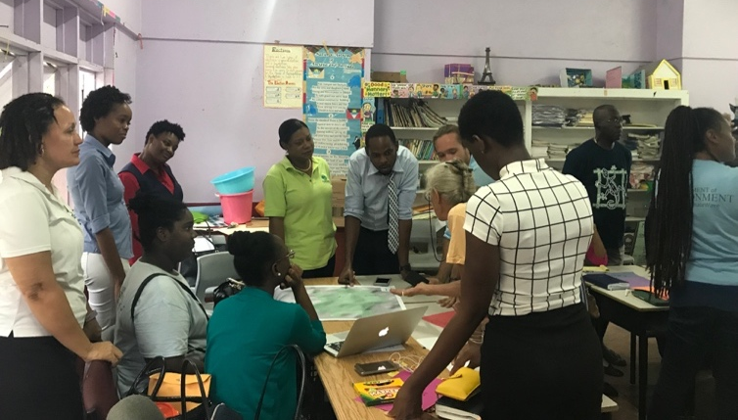
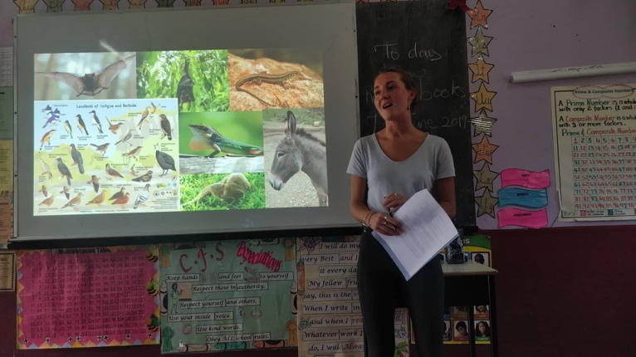
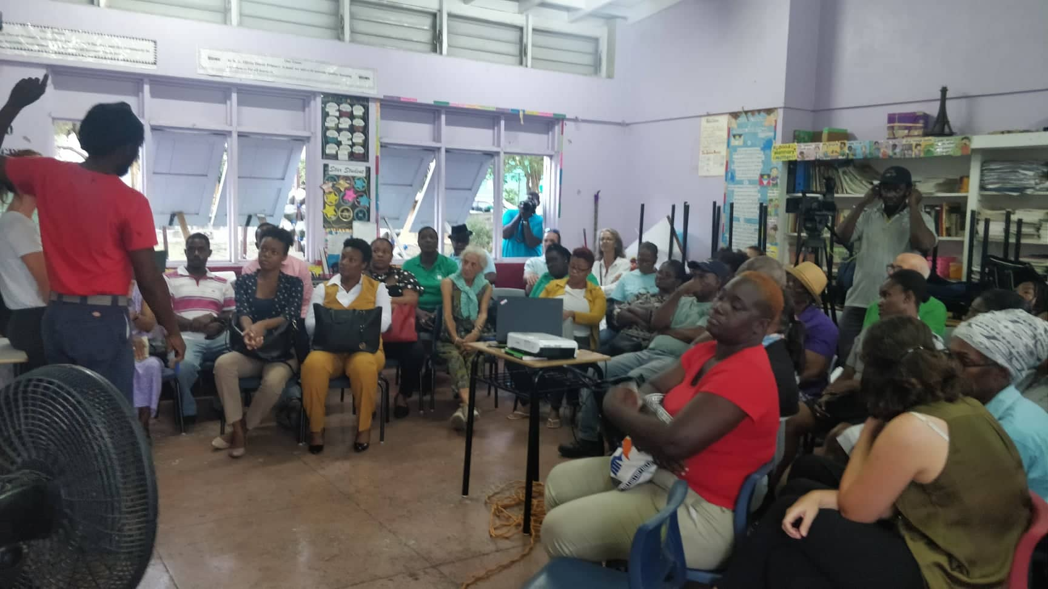
Feature Story: “Protect Boggy Peak” - Community workshops for the Protection of Boggy Peak National Park
Two community consultations were held with stakeholders living and working in communities surrounding the proposed Boggy Peak (BP) National Park in Antigua. Both workshops were held in St-Mary’s parish at SR Olivia David Primary School in May 2019. The SPPARE project team designed these workshops to increase community input in the management process, secure support for the initiative and access local knowledge that is imperative to the effective management of the proposed park.

The first workshop focused on introducing plans for BP as a protected area and informing the community about the importance of biodiversity conservation and ecosystem services. The project team utilised this time to engage community members in activities to gather valuable information regarding the aspects of the land stakeholders most valued as well as the threats impacting these uses. This information was used to create a community-wide ‘vision’ for the proposed park. The first workshop was a great success with over 50 persons in attendance. The workshop had representation from Forestry, Community Development Authority, Development Control Authority, Wallings Nature Reserve staff, the Environmental Awareness Group, Tourism, Agriculture and Police as well as Cabinet member and Saint Mary’s Parish Representative Samantha Marshall.
In the second workshop, stakeholders were invited to take part in a participatory mapping exercise to discuss current uses of the land as well as best/sustainable and unwanted practices. This information will be used to ensure spatial management and regulations are in line with current uses and needs. This workshop was attended by over 40 persons. A major topic of discussion was the importance of conservation, especially as it relates to the conservation of traditional knowledge, which is necessary for environmental stewardship and sustainable use of the land.

The SPPARE project team recognizes the value of meaningful stakeholder engagement that goes beyond informing the public of DoE activities by seeking their input and active involvement in the process. Information gathered from community members is invaluable to the development of a National Park management plan that not only reflects current land-uses and practices but also considers the communities goals towards sustainable development within the area.
A group of stakeholders discuss current uses and practices during the participatory mapping exercise in Workshop 2.
Hali Chesher (Project technical officer) discusses flora and fauna at BP in workshop 1.
Chester Samuels (Agricultural Extension division) discusses the issue of freshwater management and drought in the area during workshop 1.

Annex 2 – continued: Stakeholder engagement and site visits
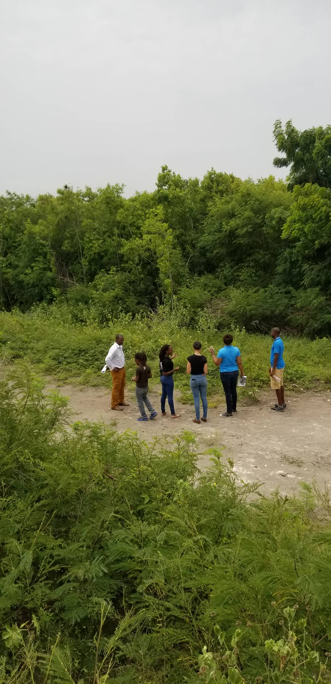
Architect Colin John-Jenkins reviews the revised building drawings with Contractor Ebeny Dey for the construction of the Boggy Peak Interpretation Centre.
The SPPARE Renewable Energy Technical Officer Kent Noonan, DoE interns and the Geotechnical Works Contractor Mr. Evron Zachariah visit the Parham ridge site where 11 turbines will be placed.
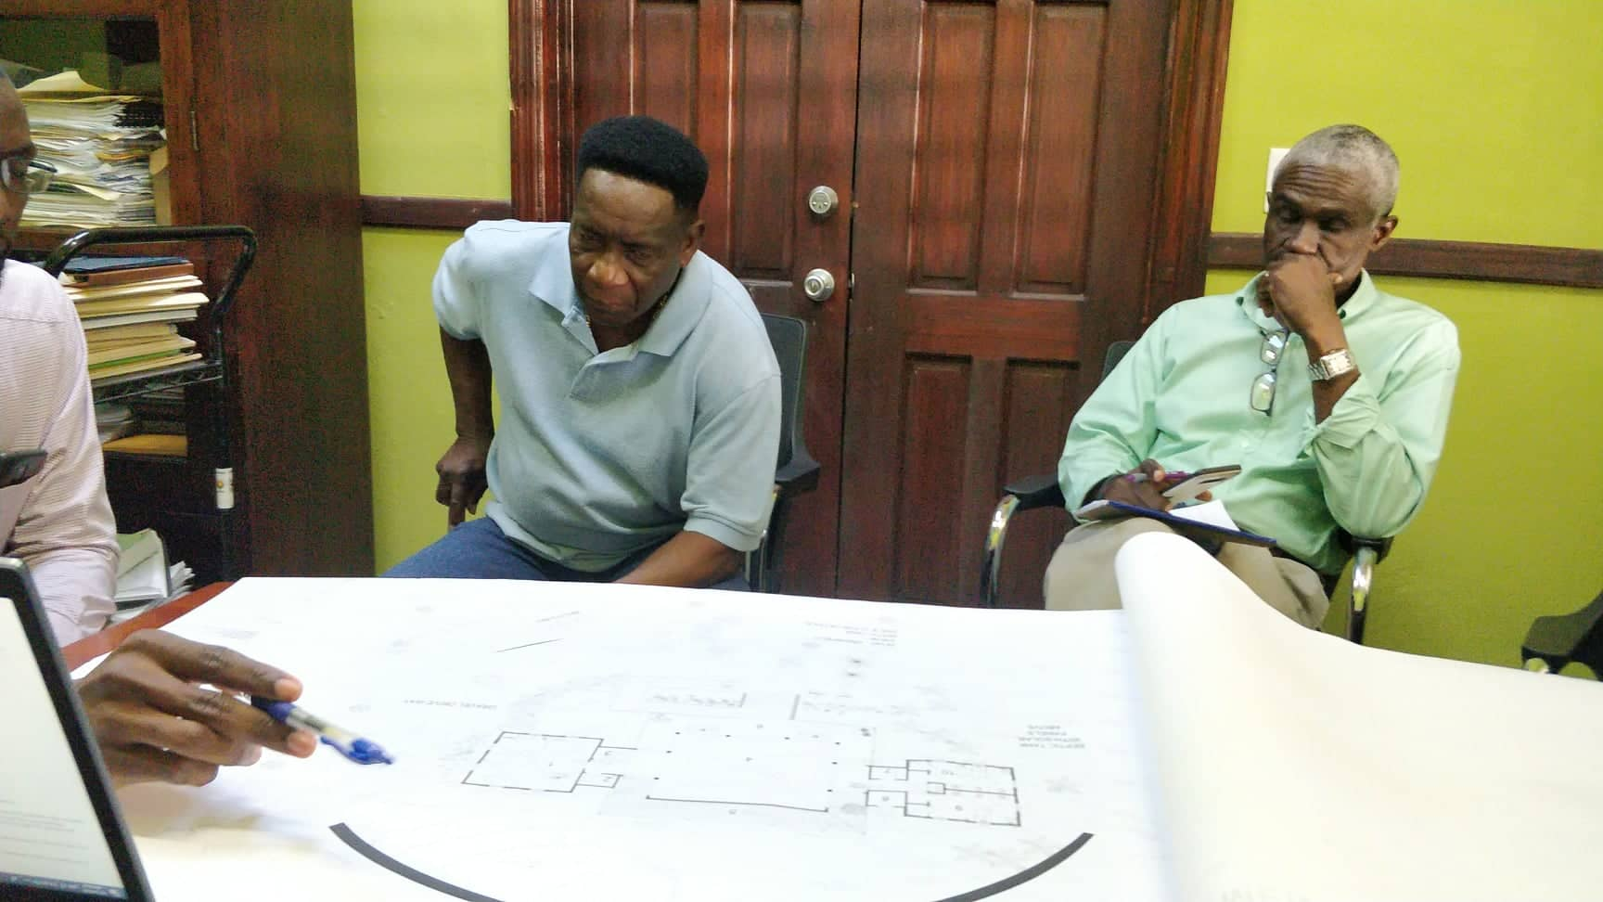
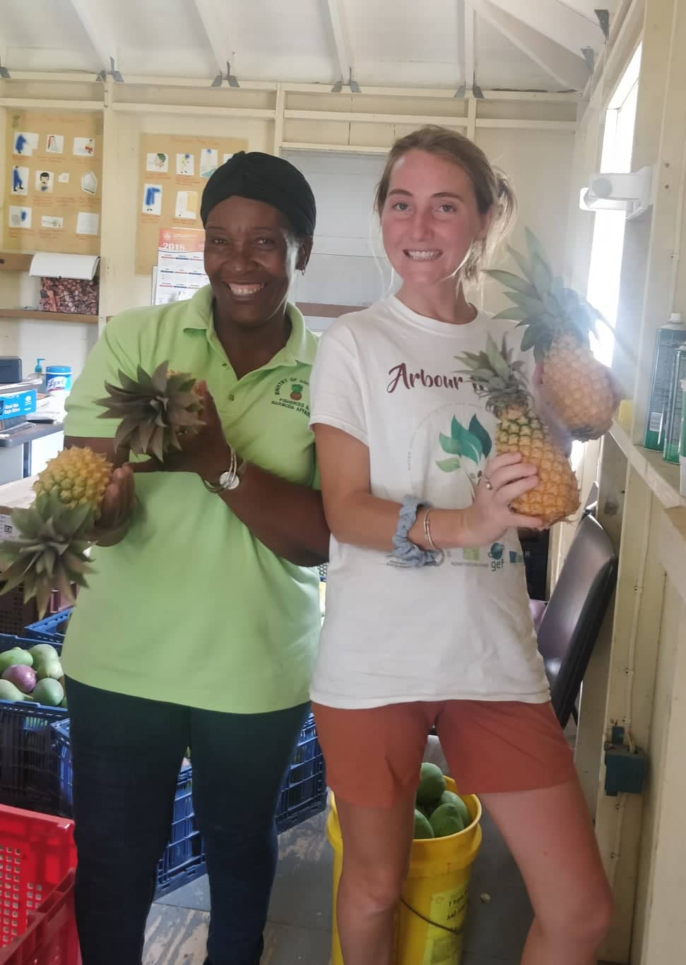
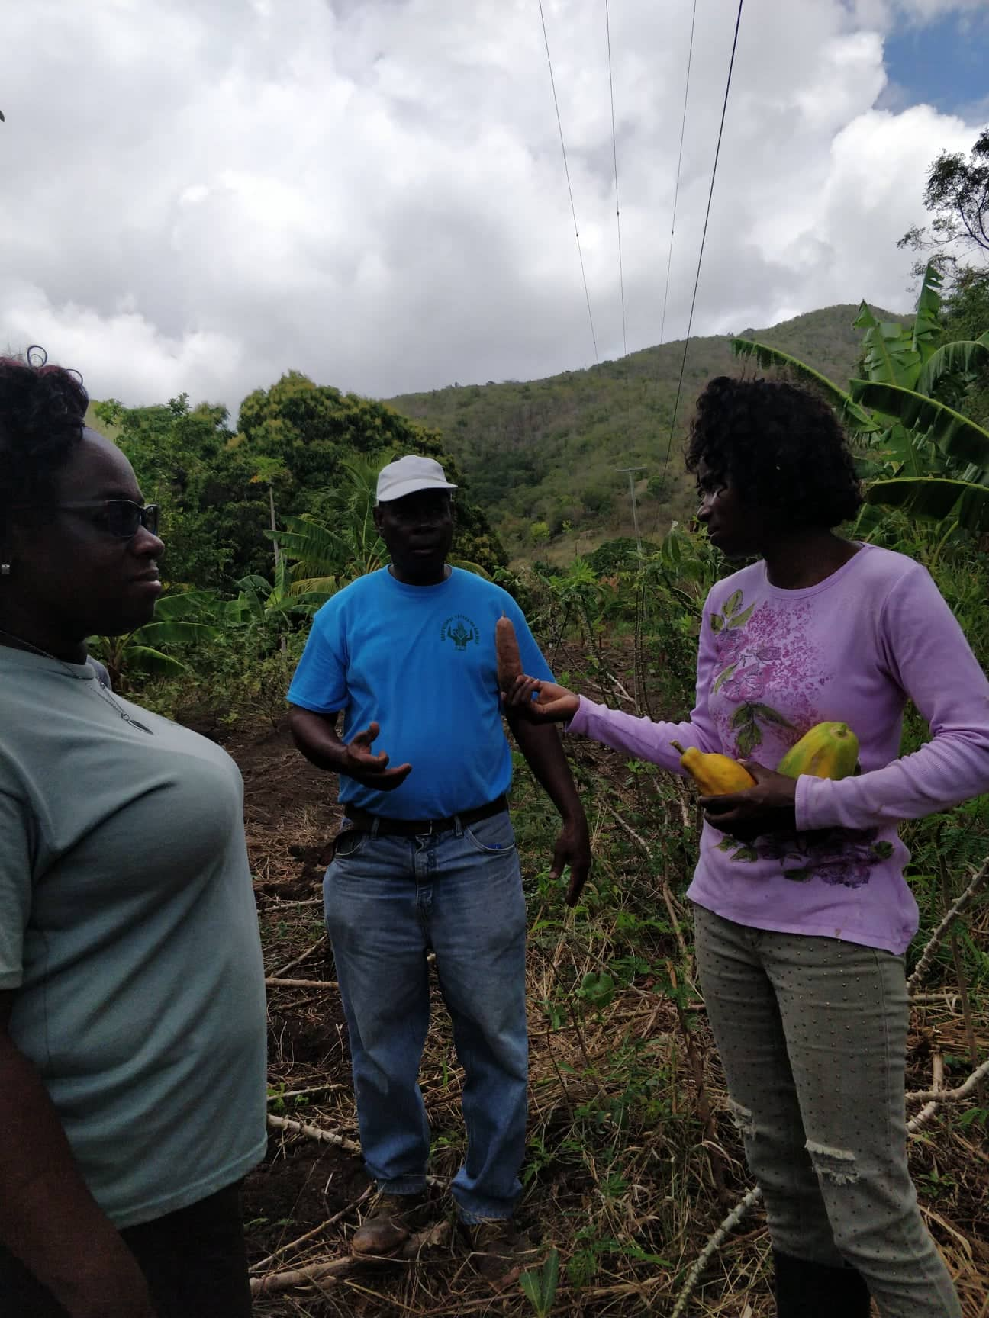

Project Technical Officer Hali Chesher visits the Cades bay agricultural station to discuss the proposed national park at Boggy Peak.

Department of Agriculture’s extension division officer Mr. Milton Barnes brings the DoE team to visit farms in the Boggy Peak area to discuss sustainable agricultural practices.

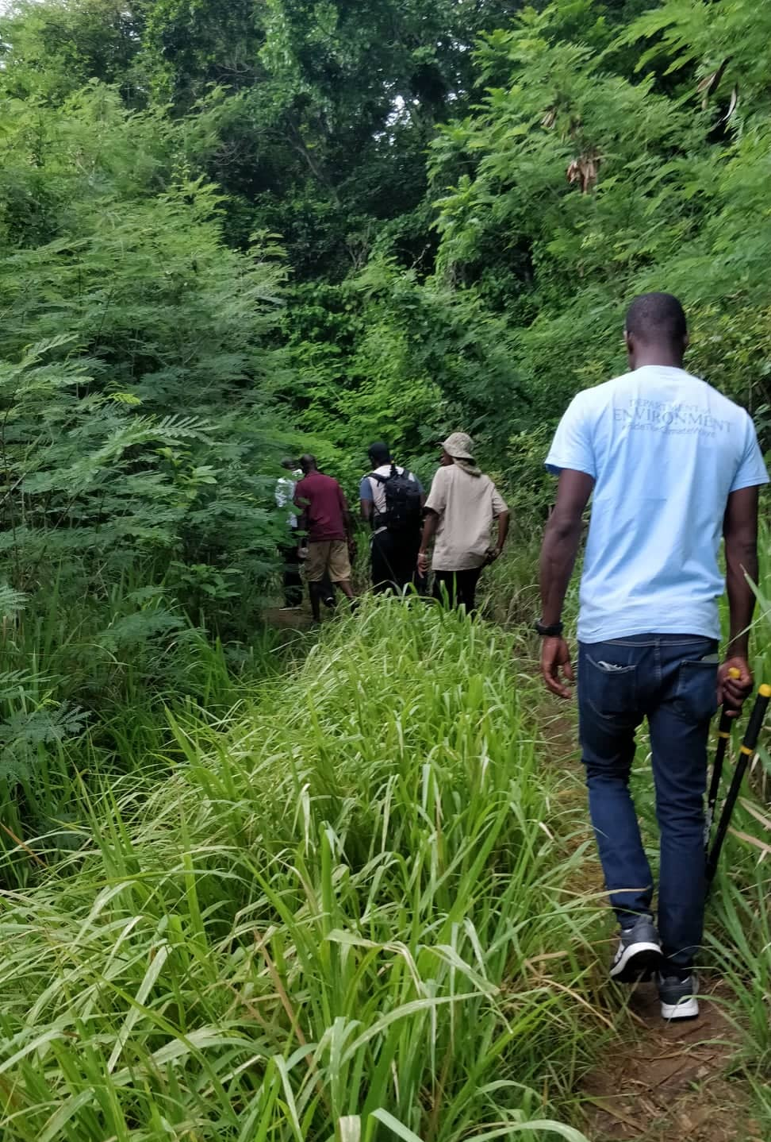

Department of Forestry rangers bring the DoE team up the Boggy Peak trail to map, tag and cut trail to peak.

For joint projects and where applicable ratings should also be discussed with the Task Manager of co-implementing agency.
Add rows if your project has more that 3 key indicators per objective or outcome.
Depending on selected indicator, quantitative or qualitative baseline levels and targets could be used (see Glossary included as Annex 1).
Many projects did not identify Mid-term targets at the design stage therefore this column should only be filled if relevant.
Use GEF Secretariat required six-point scale system: Highly Satisfactory (HS), Satisfactory (S), Marginally Satisfactory (MS), Marginally Unsatisfactory (MU), Unsatisfactory (U), and Highly Unsatisfactory (HU). See Annex 2 which contains GEF definitions.
Outputs as described in the project logframe or in any updated project revision.
As per latest workplan (latest project revision)
Implementation may be assessed by qualitative assessments, percentage of delivery, and/or budget expenditure (planned and actually spent). The 2018 assessment should be copied from previous PIR.
To be provided by the UNEP Task Manager
Use GEF Secretariat required six-point scale system: Highly Satisfactory (HS), Satisfactory (S), Marginally Satisfactory (MS), Marginally Unsatisfactory (MU), Unsatisfactory (U), and Highly Unsatisfactory (HU)
Only for Substantial to High risk.

